New front mowers: NOVACAT F
Smooth and cost effective mowing

The Austrian agricultural machinery manufacturer Pöttinger is well-known for its expertise in grassland farming. Careful mowing forms the basis for high quality forage. The new NOVACAT F front mowers enable smooth and cost effective mowing. The mowers are available with working widths of 2.62 m or 3.04 m.

Focus on cost effectiveness
The NOVACAT F series combines low weight with maximum strength. Thanks to the compact three-point linkage mounted headstock, the centre of gravity is close to the tractor, making it easy to use even with small tractors. The mower also handles extremely well on steep terrain.

Best chopping quality
The heart of the NOVACAT F is the cutter bar, proven over thousands of cuts in the field. The cutter bar is just 4 cm high to guarantee optimum crop flow. And because it is only 28 cm deep, it delivers the best ground tracking. Gimbals on the cutter bar guide arms guarantee multidimensional freedom of movement. The arc of movement of +/- 8 degrees allows the mower to float precisely over all undulations in the ground. The weight of the mower is carried either by the tractor hitch, or optionally by two strong suspension springs between the headstock of the mower and the mounting bracket on the tractor.

Convenient and safe
The side guards are folded upwards for safe road transport, and hydraulic folding is available as an option. Because the guards fold well away, optimum access is provided to the cutter bar. This makes it possible to clean the machine thoroughly and change blades quickly and easily.

Pöttinger's NOVACAT F front mowers offer a combination of cost effectiveness, the best cutting quality and convenience to meet farmers' highest expectations.

Photo preview:
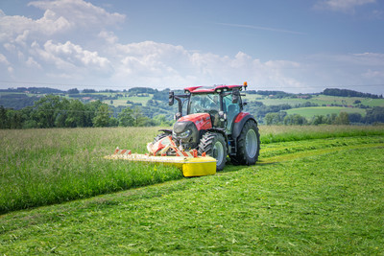 | 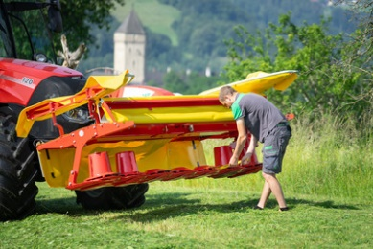
NOVACAT F for smooth mowing | Stability and strength are what make the NOVACAT F stand out
https://www.poettinger.at/de_at/newsroom/pressebild/135626 | https://www.poettinger.at/de_at/newsroom/pressebild/135625

More printer-optimised photos: www.poettinger.at/presse

